ASSIGNMENT 2
FINAL LAB TASKS BY OM 2280156
COURSE CC

LAB 2

TASK 1: IMPLEMENT MANAGEMENT GROUPS

Azure Management Groups Overview
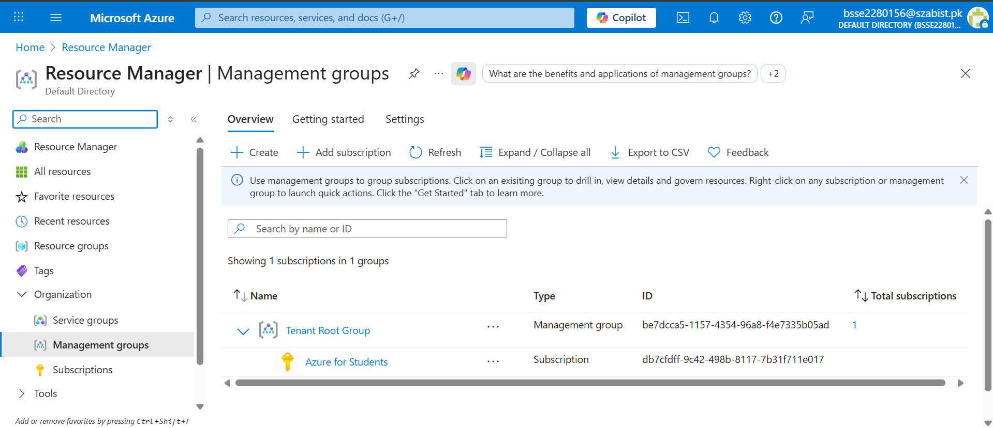

Creation of Management Group
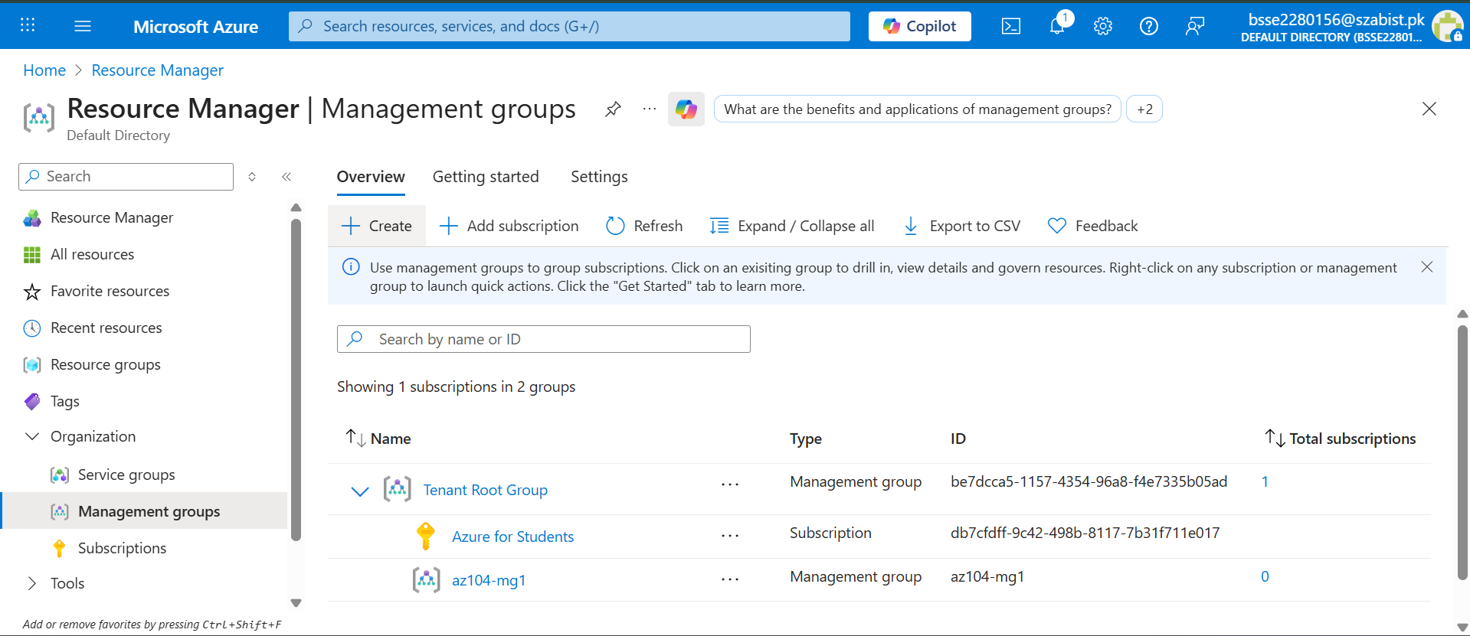
TASK 2: ASSIGN BUILT-IN RBAC ROLE

Built-in RBAC Roles Overview
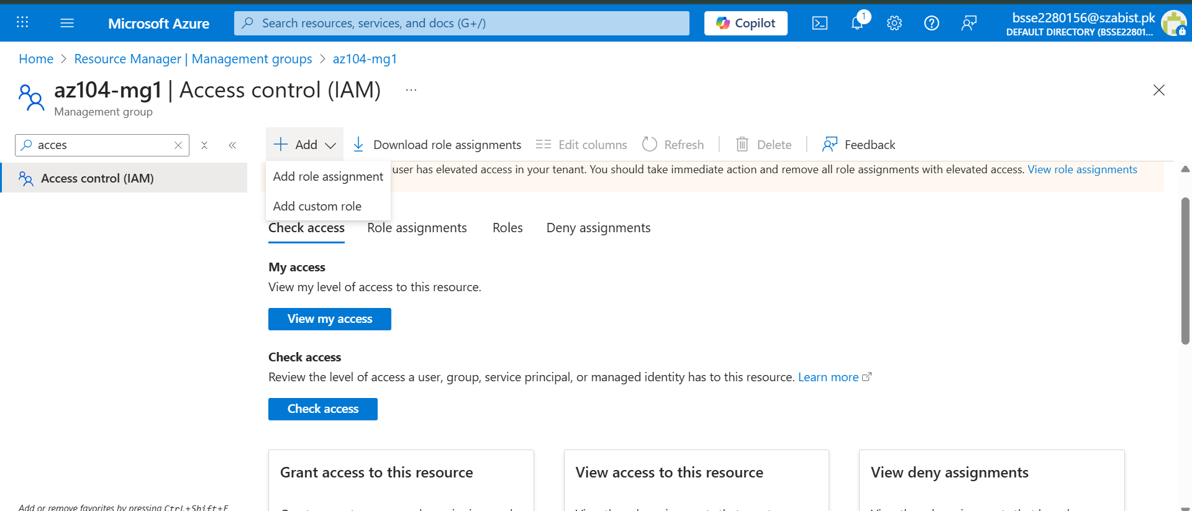
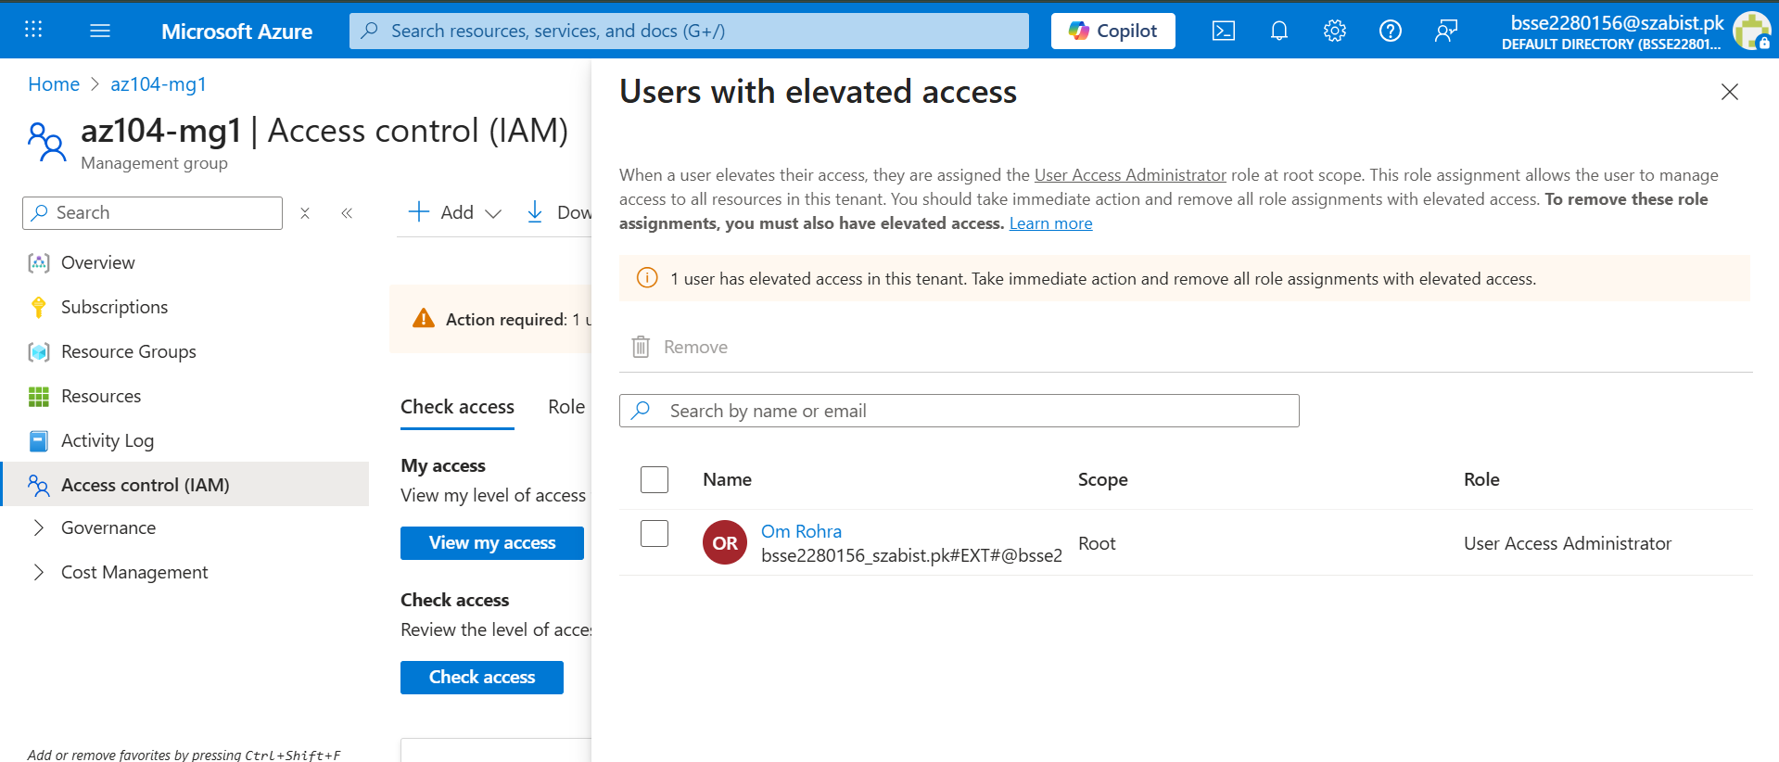

Assignment of Virtual Machine Contributor Role
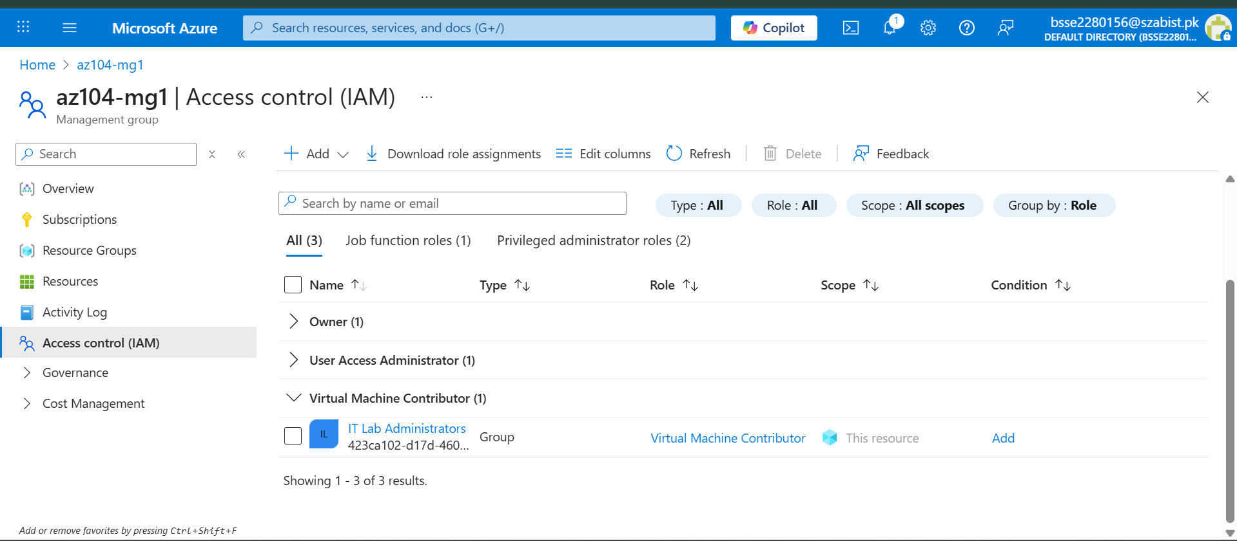

TASK 3: CREATE CUSTOM RBAC ROLE

Custom RBAC Role Creation – Basics
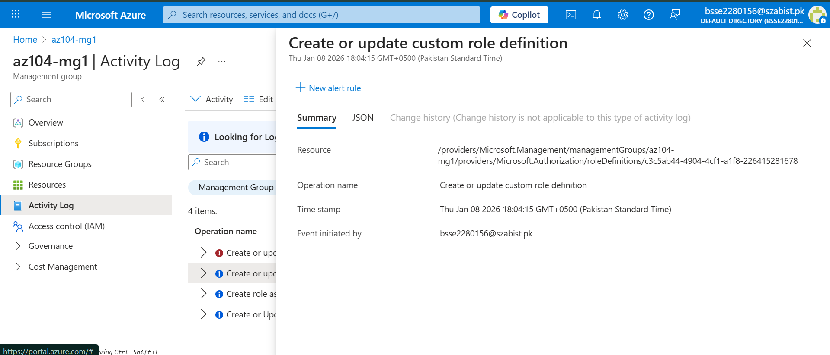

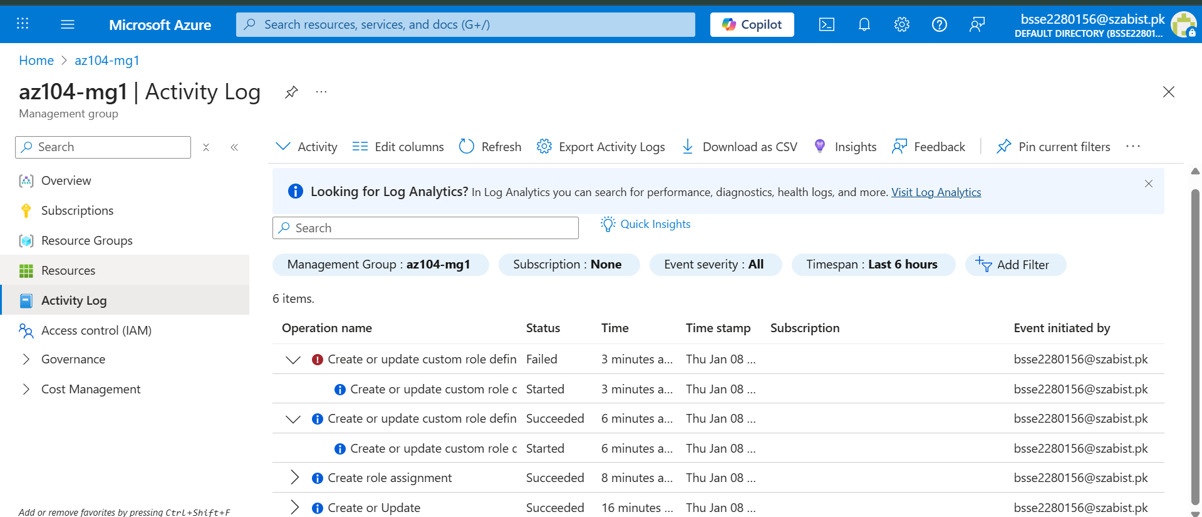
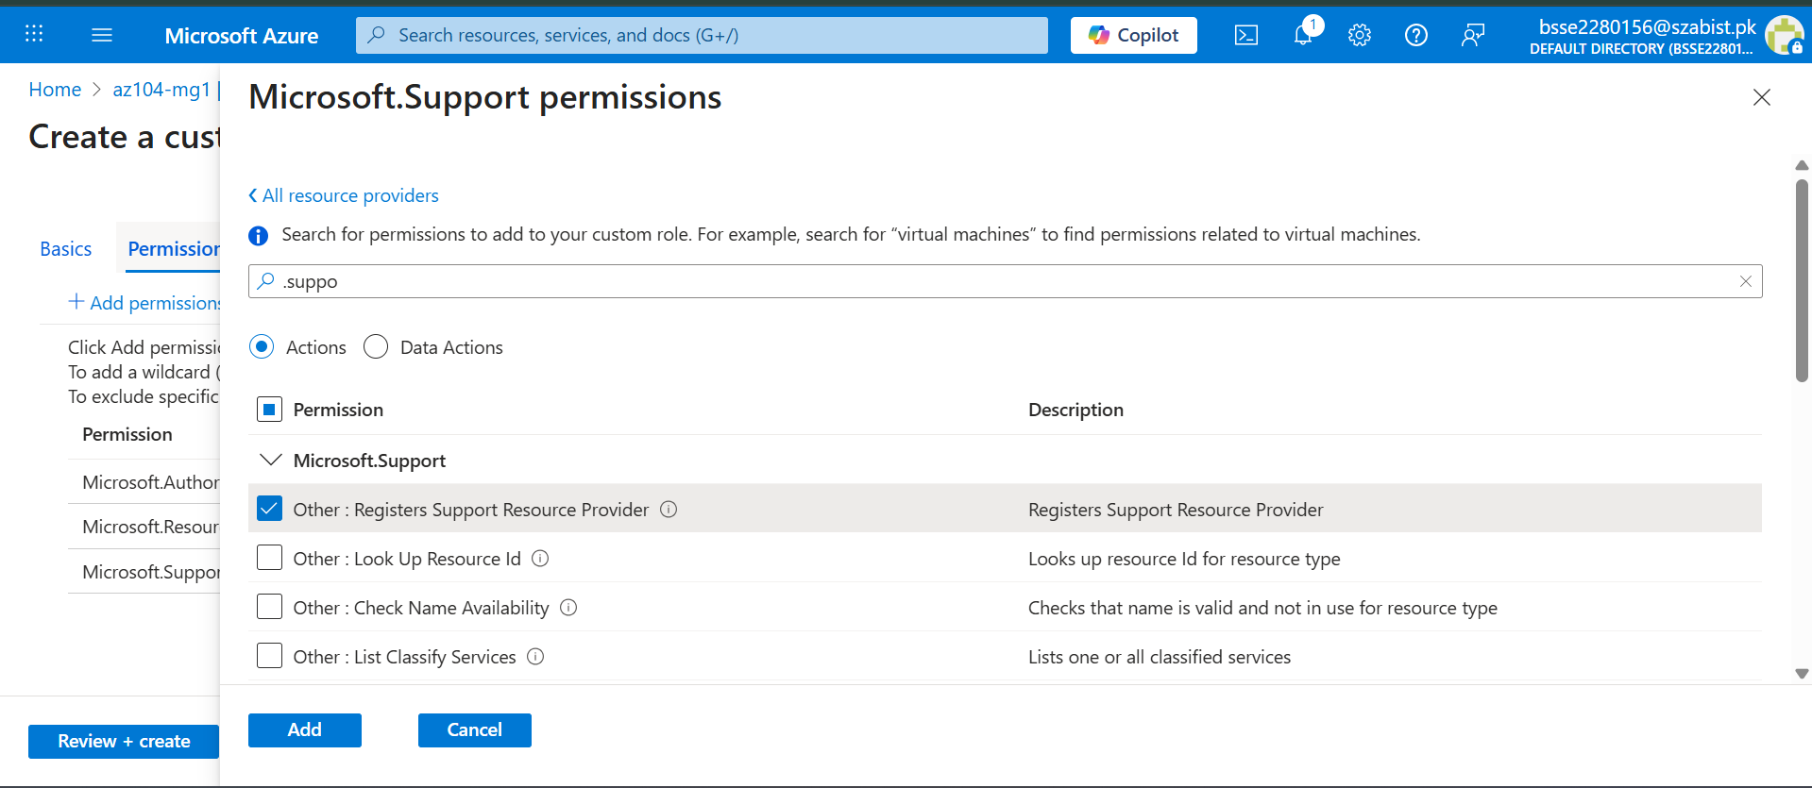
Custom RBAC Role Permission Configuration
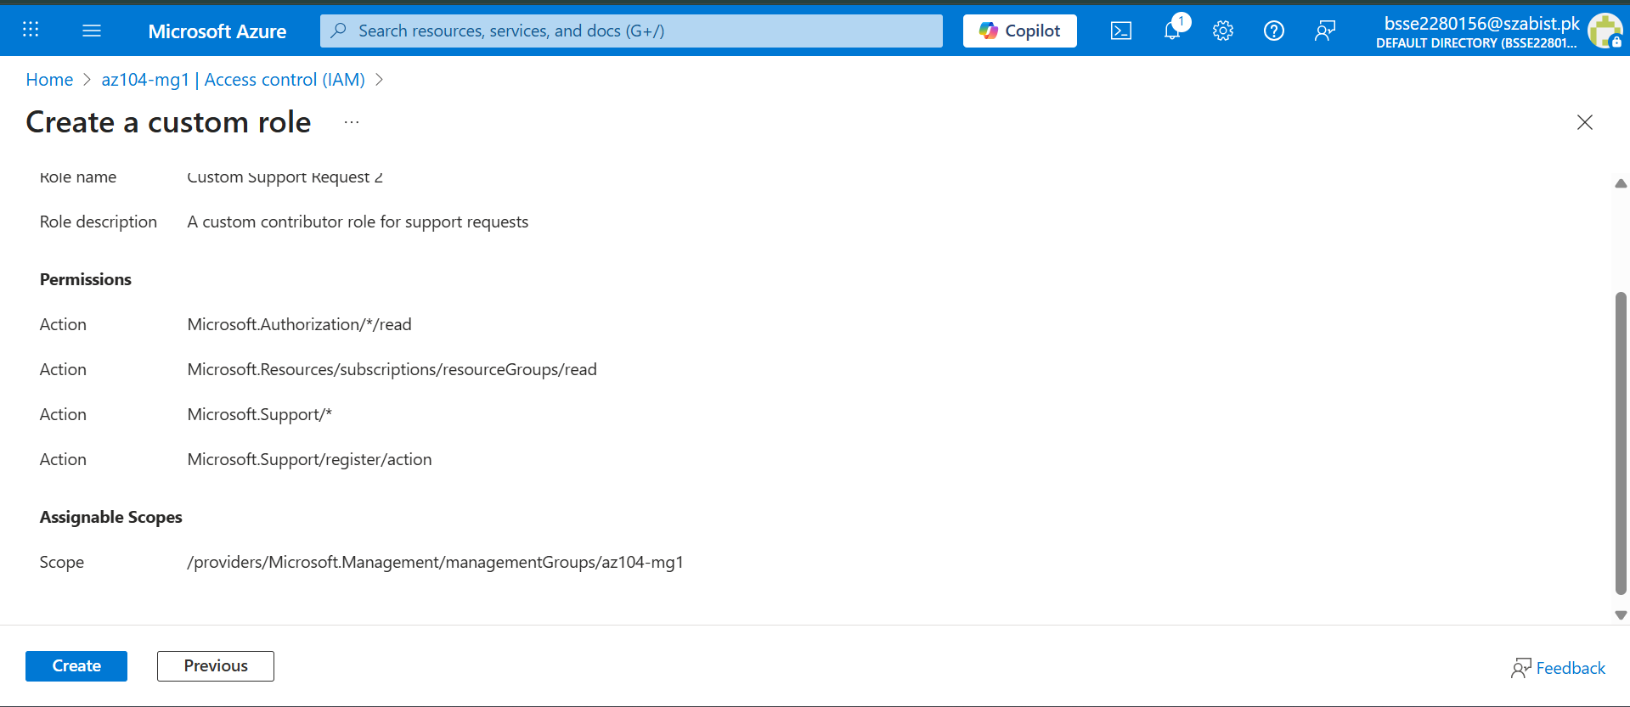
TASK 4: ACTIVITY LOG VERIFICATION

Monitoring RBAC Changes Using Activity Log
